As we can see in the c file 1024 bytes are stored in a string
Overflow isn’t apparent as we can see a set buffer size for the input and a manual set of the last byte to a nop
The name is immediately printed without any validation of the input
This immediately makes me think of leaking addresses off the stack using %p
Let me checksec this program
Pie is disabled meaning we don’t actually need to do any address leaking
As we can see the win condition is bug being different from 0
Meaning we are expected to use the format %n which writes to whatever address I provide the number of bytes printed so far
Since format string reads from the stack, We have to get bugs address to the stack (copy it to name with the input)
And we must identify how many stack indices separate the printf and the name (so we can use %7$n to use %n on the 7th argument -> meaning the 7th stack item above printf)
Lets start with getting bug’s address using gdb since pie is disabled and then print AAAA and print each stack argument and see where our A is (0x41414141) like this: %1$p %2$p %3$p %4$p %5$p %6$p %7$p %8$p %9$p
As we can see we use the 6th variable so now we will input the adress of bug and do %6$n
Lets find bug’s adress
Now lets input that in little endian and write a script for the payload
Payload should be the adress followed with padding and then %6$n
I wrote a simple payload 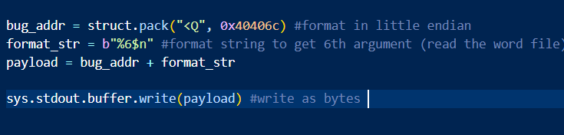
It didn’t work because as u can see the adress gets a padded 2 \00 becauase its only 6 bytes. In c that is a null operator which signals the end of a string, so the %6$n never runs.
I tried adding padding and it doesn’t work, so ill debug with this fmt string %6$p %7$p %8$p %9$p\n
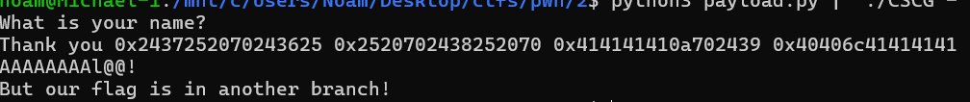
As we can see the AAAA and then bug addr in arg %9, so we need to cut off the A padding by 4 A’s
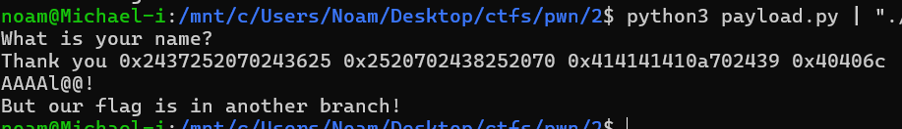
Nice now bug addr is alone, lets just jump to it.
Stupid mistake of mine, now that we revert the fmt string to its original form the stack alignment changes cuz the string size changed.
I just changed the %9$p to %9$n and it worked!

